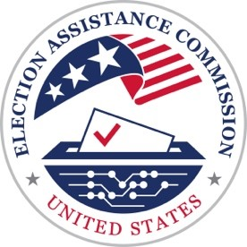
U.S. Election Assistance Commission
Scripts for the Be Election Ready: Video Guides for Voters Series

Video 6: Election Results

U.S. elections are purposefully designed with layers of security protocols and robust processes to ensure that every vote is counted and that the results are trustworthy.
This means that the final election results cannot often be reported on election night, and what many voters see on news reports are considered “unofficial” until certified.
U.S. elections are not run at the federal level. They are managed independently across thousands of local jurisdictions – who follow the unique laws of their respective state.
Not only do voting methods differ from state to state, there are also different processes for counting ballots and reporting results, all based on each state’s unique laws.
Let’s explore what this means for election results.
First, when election officials and the media begin reporting results in real-time after the polls close on Election Day, those results are not final – because all the ballots have not yet been counted.
In different states, ballots cast through different methods are counted and reported at different times and in different orders.
For example, some states will report Election Day votes before votes submitted by mail. Whereas other states start processing vote-by-mail ballots prior to Election Day – meaning they will report those results sooner.
Some ballots – like provisional ballots – require a thorough review before they can be counted, and are only counted if the voter is eligible.
Since each state has different procedures, some states will complete their count before others. And, depending on the local laws, some states may also count ballots that are received after Election Day, like those from military and overseas voters.
Since ballots usually include votes in many races, election officials use tested technology and a careful counting process to count votes accurately.
Once all the votes are counted, election officials review, or canvass, the election. They check election records, make sure that the number of ballots counted is correct, and confirm that security requirements were properly followed.
Finally, once all records are confirmed the election results are certified.
Finalizing elections in the U.S. takes time. But, trustworthy results are always worth the wait.
For more information contact your state or local election office or visit EAC.gov.

