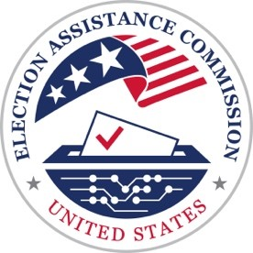
U.S. Election Assistance Commission
Scripts for the Be Election Ready: Video Guides for Voters Series

Video 5: Trusted Sources of Information

With so much attention focused on elections and voting, who should voters turn to for information they can trust?
The answer: state and local election offices.
Because elections are run at the state and local level, no two state’s election processes are exactly the same. That’s why it’s important for voters to go directly to their election official to get the information that is most relevant for them.
In addition to serving as a go-to resource for voters, election officials also:
Keep ballots safe and secure;
Make sure voter registration lists are accurate and up to date, so only eligible voters can cast a ballot;
Provide transparency, including opportunities for the public to observe election processes and ballot counting ;
Test and secure all voting equipment before each election; and
Carefully review election records for accuracy before declaring the results of an election are final.
The U.S. Election Assistance Commission is also a reliable source of information. As the sole federal agency dedicated exclusively to election administration, the EAC assists election officials and helps voters participate in the voting process across the country.
For any questions about:
Registering to vote;
How to obtain a ballot;
The voting process;
And election results you can rely on your state and local election officials.
The best information is from an official source.
For more information, contact your state or local election office, or visit EAC.gov.

