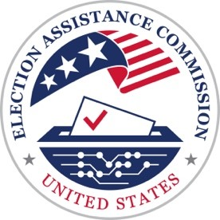
U.S. Election Assistance Commission
Scripts for the Be Election Ready: Video Guides for Voters Series

Video 4: Voting in Person

These days there are more ways to vote than ever. But data shows that the most popular way is still in person at a voting location.
If you’re planning to vote in person this election, you’ll need to ask yourself two questions.
One. When can I vote?
And two. Where can I vote?
Many states and territories allow voters to cast their ballot at a voting location before Election Day. This is also known as early voting.
Since the rules vary state-by-state, it’s important to check with your local election office to see if you have the option to vote early or if in person voting is only available on Election Day.
Once you know when you can vote, you need to know where you’re going.
Most voters are assigned to one voting location within their community, but some states allow voters to choose one of several locations to visit.
To ensure that you are going to the right place – at the right time – look up your voting information on your state election website or contact your local election office.
When you arrive at your voting location, there will be election workers ready to assist you.
Typically, you will be asked your name and may need to share some details like your address, date of birth, or provide a signature.
You may live in a state that requires a valid ID to vote, so make sure to double check the rules before going to vote.
After an election worker verifies your registration, you’ll be given a ballot to fill out.
If you have any questions, the election workers on site will help you.
After filling out your ballot, you’ll place it in a ballot box, tabulator, or cast your ballot directly on the voting device.
Congratulations, you just voted!
Don’t forget your “I Voted” sticker.
For more information contact your state or local election office or visit EAC.gov.

