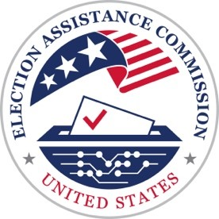 | U.S. Election Assistance Commission  Scripts for the Be Election Ready: Video Guides for Voters Series (30 Seconds)

Video 2: Making a Plan to Vote
If you want to vote, it’s important to understand the options available in your community.
Making your plan to vote is simple.
First, make sure you’re registered.
Check your status at vote.gov.
Next – determine how, when, and where you’ll vote.
You may have a few options to vote before Election Day.
And voting on Election Day is always an option.
For more information, contact your state or local election office or visit EAC.gov.

